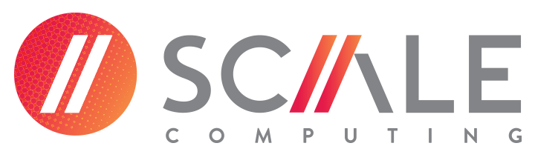
Product Manager - Edge Computing

Fast. Dynamic. Energetic. Honest. These are just a few of the words used to describe the culture in the Scale Computing offices around the world. Our employees are intelligent, enthusiastic, entrepreneurial, and they actively create the vision that is Scale Computing.

Scale Computing, Inc. is seeking a Product Manager focused on our HC3 Edge solution to join our growing team! This position reports to the VP of Product Management. The ideal candidate has experience in working with various stakeholders (customers, sales team including systems engineers, channel partners, product engineering and others) to represent the voice of the customer. This position will be vital in planning the product roadmap and delivery of our edge focused product line.

Responsibilities Duties:
- Help define and develop product strategy and roadmap for the HC3 Edge solution, prioritizing the backlog of features
- Oversee ongoing Win/Loss analysis in existing markets
- Collaborate with product marketing on the positioning for the HC3 Edge solution and features
- Work hand-in-hand with product development to clarify user stories/release requirements and generally removing roadblocks in the implementation details for new features
- Oversee documentation around releases and communication on progress within the company
- Understand the competitive products and articulate product gaps/strengths vs. the HC3 Edge solution

Qualifications:
- 3-5 years+ of product management experience
- Strong preference for a background in virtualization technology, IT infrastructure, or cloud technologies
- Track record of using qualitative and quantitative data to prioritize and drive decision-making
- Experience with agile scrum development and lean startup principles
- Ability to communicate effectively across functional teams to build consensus
- Position requires domestic and international travel to customer/partner sites up to 20%
Our Work Environment:
Our team is small and collaborative, so you'll get to make an impact on the product, team, and company within your first few months.
Perks and benefits:
- Flexible hours
- Work from home opportunities
- PTO
- Full medical coverage
- 401k
- Life and disability insurance

We are unable to provide work visa sponsorship at this time. No recruiters please.

